Roll No.:2503a52531
Name: B.Poojitha
Batch:18

Question 3: Few-Shot Prompting (Armstrong Number Check)
Write a few-shot prompt by providing multiple input-output examples
to guide the AI in generating a Python function to check whether a
given number is an Armstrong number.
Examples:
• Input: 153 → Output: Armstrong Number
• Input: 370 → Output: Armstrong Number
• Input: 123 → Output: Not an Armstrong Number
Task:
• Analyze how multiple examples influence code structure and
accuracy.
• Test the function with boundary values and invalid inputs.

Prompt:
Write a Python function to check whether a given number is an Armstrong number.
Examples:
Input: 153 → Output: Armstrong Number
Input: 370 → Output: Armstrong Number
Input: 123 → Output: Not an Armstrong Number
Now generate the Python code based on these examples.

Code:
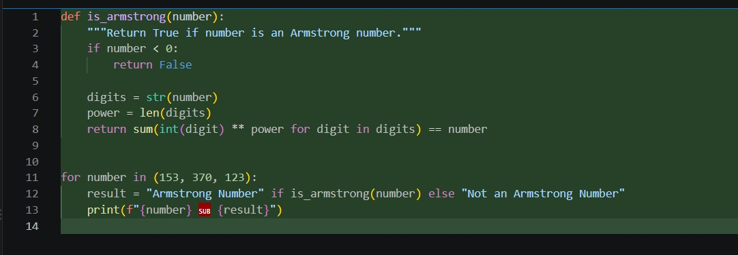
Output:
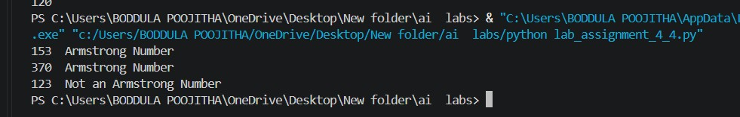

Observation:
1. The few-shot prompt generated a Python function to check whether a number is an Armstrong number.
2. Multiple examples helped the AI understand the expected logic and output format clearly.
3. The generated code correctly identified Armstrong numbers such as 153 and 370.
4. It correctly identified 123 as a non-Armstrong number.
5. The multiple examples improved the accuracy and structure of the generated code compared with zero-shot prompting.
6. Boundary values such as 0, 1, and single-digit numbers were tested and handled appropriately.

